**Assignment 6**

**1.Create application which will display one textfield and one static text “Marvellous Infosystem” on page**

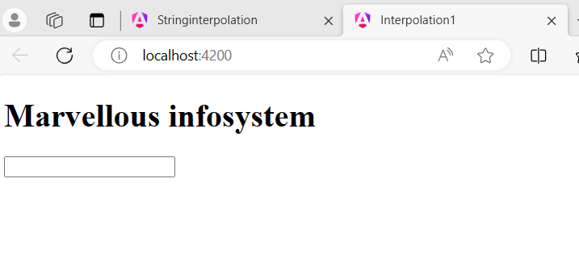

**2. Create application which will display one textfield and one static text “Marvellous Infosystem” on page Color of text should be blue**

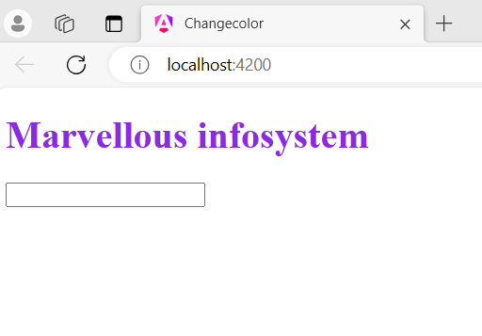

**3. create same angular application as above but instead of using app.component .html and app.component ,css file separately add its contents in inline format binside app.component .ts file**

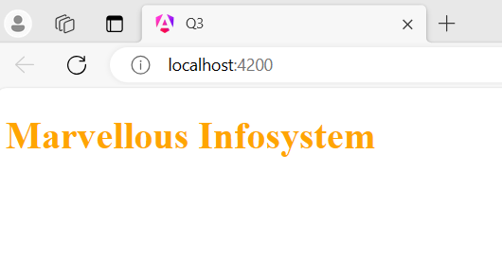

**4. create angular application which will Demonstrate the concept of string interpolation for this purpose create new component named as Newomp and render that form App Component Inside that new component add one class property as name.**

